Lab 6: Tables, Data Types and Constraints

Part 1. Creating tables

Step 1. Create a schema for this lab
A separate schema keeps Lab 6 tables apart from other labs.
DROP SCHEMA IF EXISTS lab6 CASCADE;
CREATE SCHEMA lab6;
SET search_path TO lab6;

Step 2. Create tables with data types and constraints
Uses SERIAL, VARCHAR, TEXT, INTEGER, DATE, BOOLEAN, TIMESTAMP and the constraints PRIMARY KEY, NOT NULL, UNIQUE, CHECK, DEFAULT, FOREIGN KEY.
CREATE TABLE students (
student_id SERIAL PRIMARY KEY,
first_name VARCHAR(50) NOT NULL,
last_name VARCHAR(50) NOT NULL,
email VARCHAR(100) UNIQUE NOT NULL,
faculty VARCHAR(100),
birth_date DATE,
is_active BOOLEAN DEFAULT TRUE,
created_at TIMESTAMP DEFAULT CURRENT_TIMESTAMP
);
CREATE TABLE grades (
grade_id SERIAL PRIMARY KEY,
student_id INTEGER REFERENCES students(student_id),
subject TEXT NOT NULL,
score INTEGER CHECK (score >= 0 AND score <= 100)
);
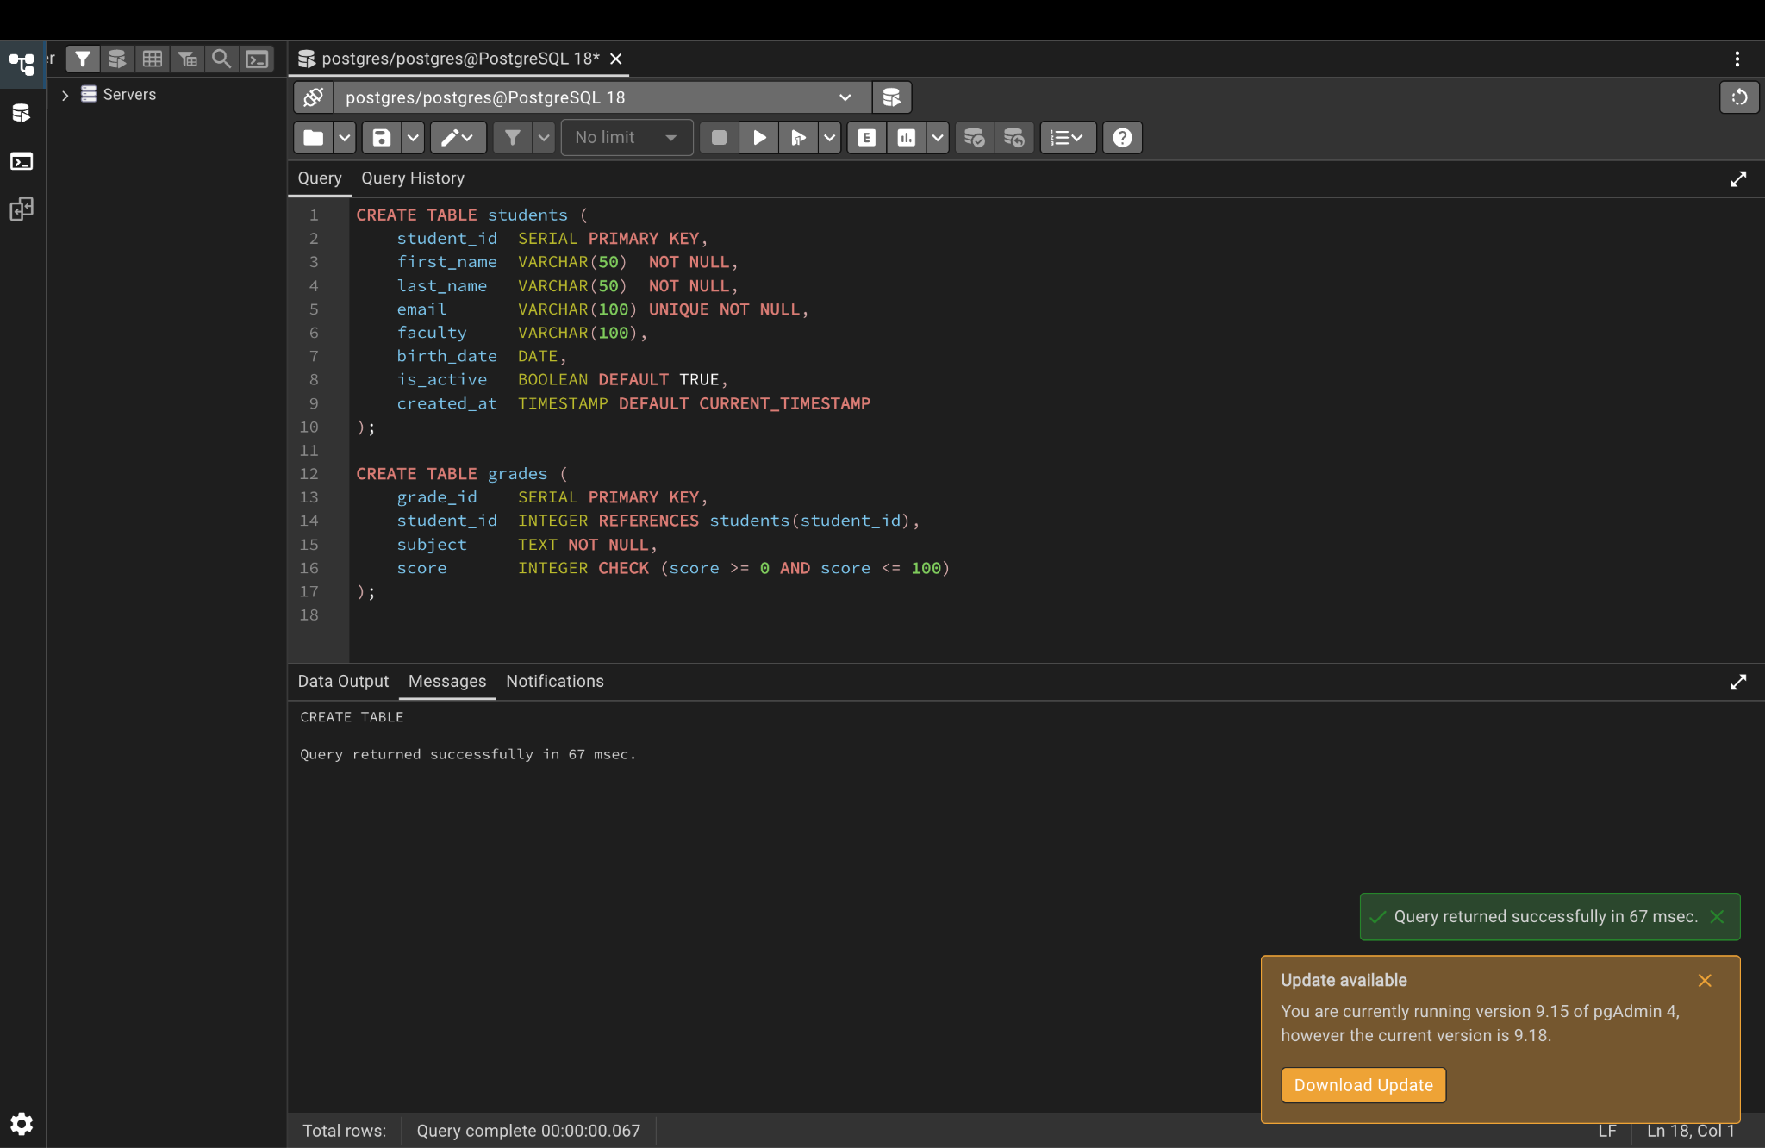

Step 3. Insert data and view it
INSERT INTO students (first_name, last_name, email, faculty, birth_date) VALUES
('Zhamilya', 'Kambaraalieva', 'zhamilya@alatoo.edu.kg', 'Computer Science', '2005-03-14'),
('Aibek', 'Toktorov', 'aibek@alatoo.edu.kg', 'Mathematics', '2004-11-02'),
('Aigerim', 'Asanova', 'aigerim@alatoo.edu.kg', 'Computer Science', '2005-07-21');
INSERT INTO grades (student_id, subject, score) VALUES
(1, 'Databases', 95), (2, 'Databases', 82), (3, 'Algorithms', 88);
SELECT * FROM students;
SELECT * FROM grades;
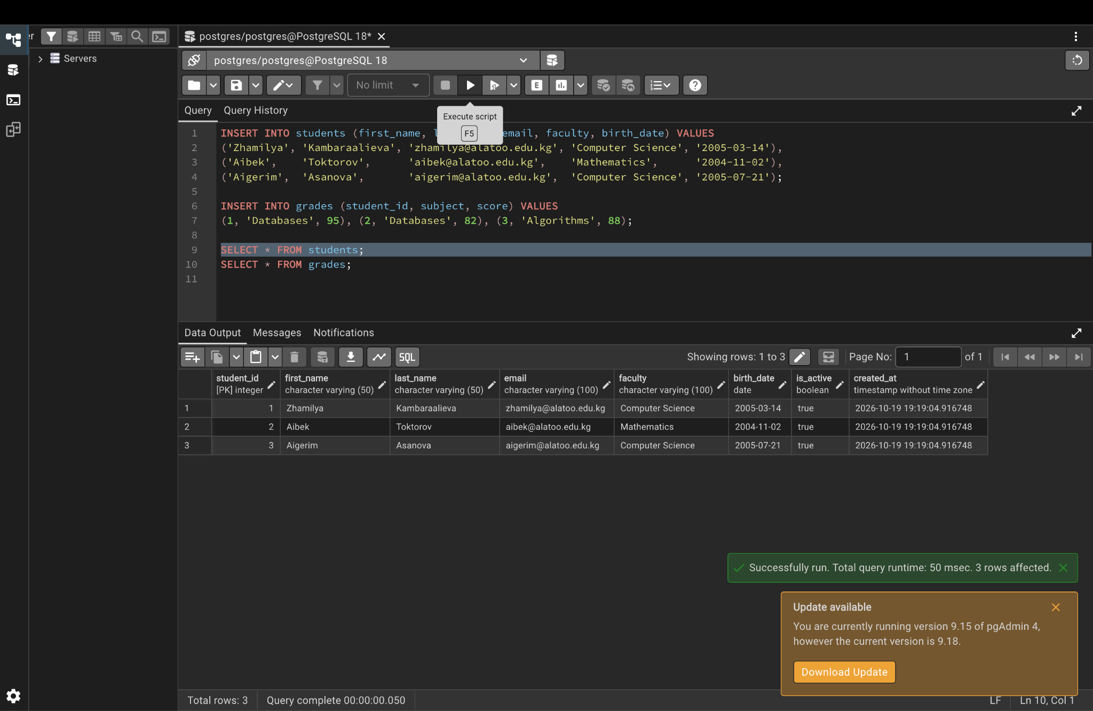
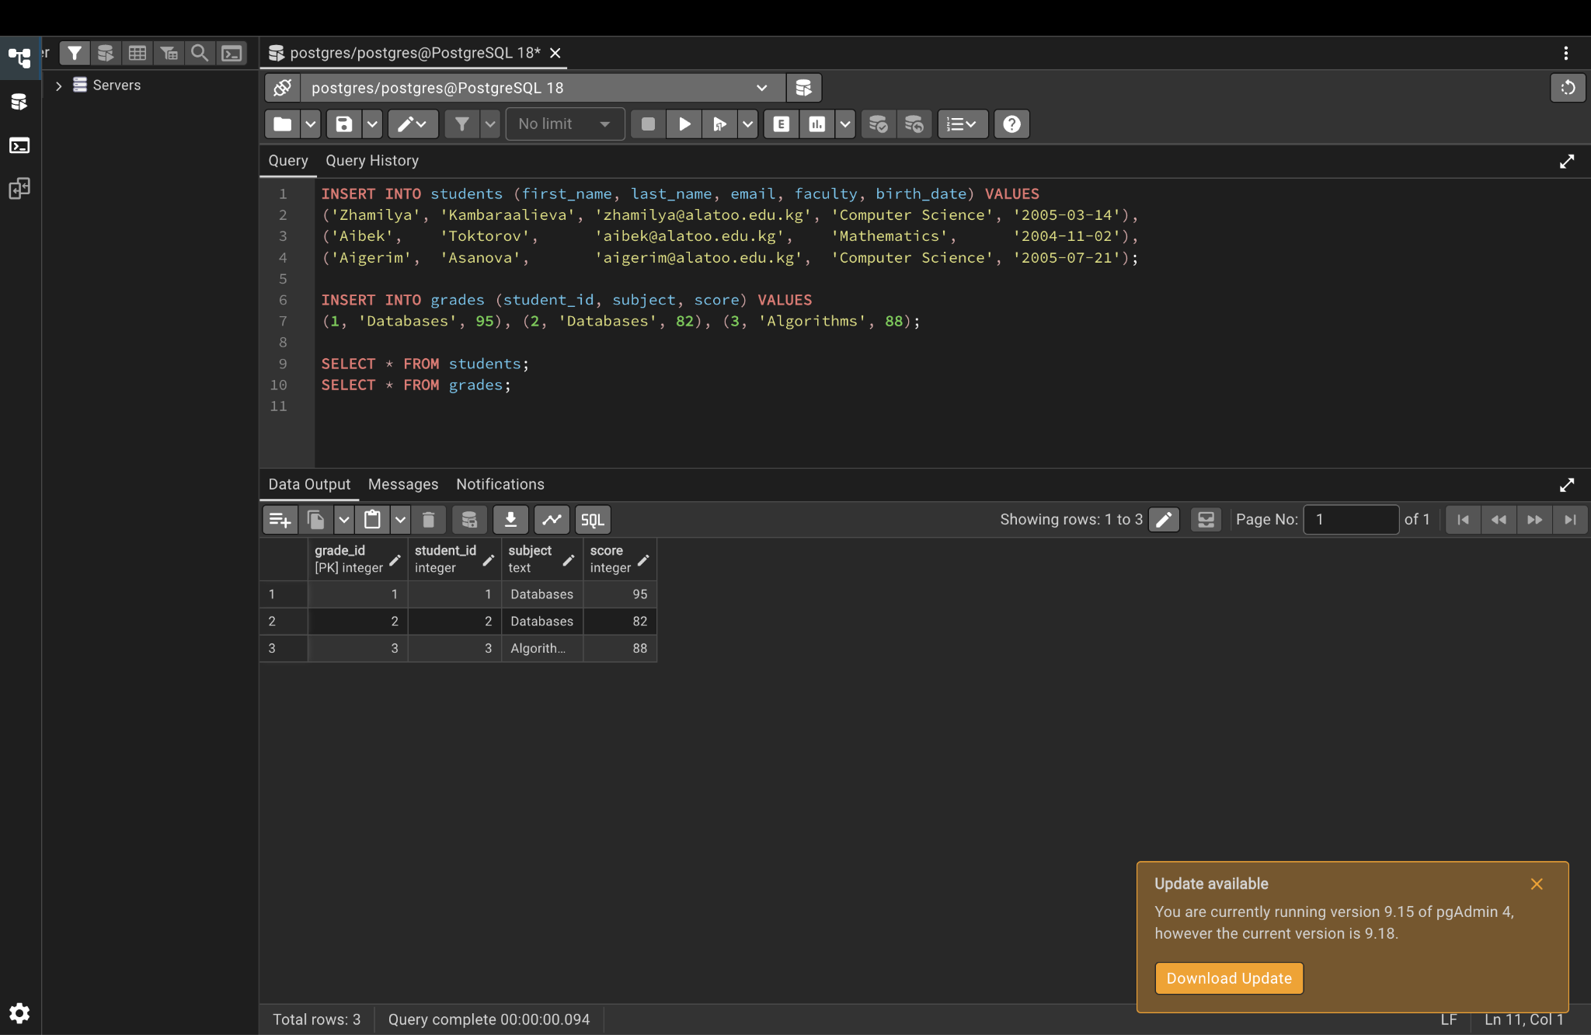

Part 2. Altering tables

Step 4. Change the table structure with ALTER TABLE
Add a column, drop a column, change a type, add a constraint, rename a column and rename a table.
ALTER TABLE students ADD COLUMN phone VARCHAR(20);
ALTER TABLE students DROP COLUMN birth_date;
ALTER TABLE students ALTER COLUMN faculty TYPE VARCHAR(150);
ALTER TABLE students ADD CONSTRAINT chk_phone CHECK (phone LIKE '+996%');
ALTER TABLE students RENAME COLUMN faculty TO department;
ALTER TABLE grades RENAME TO student_grades;
UPDATE students SET phone = '+996700123456' WHERE student_id = 1;
SELECT * FROM students;
SELECT * FROM student_grades;
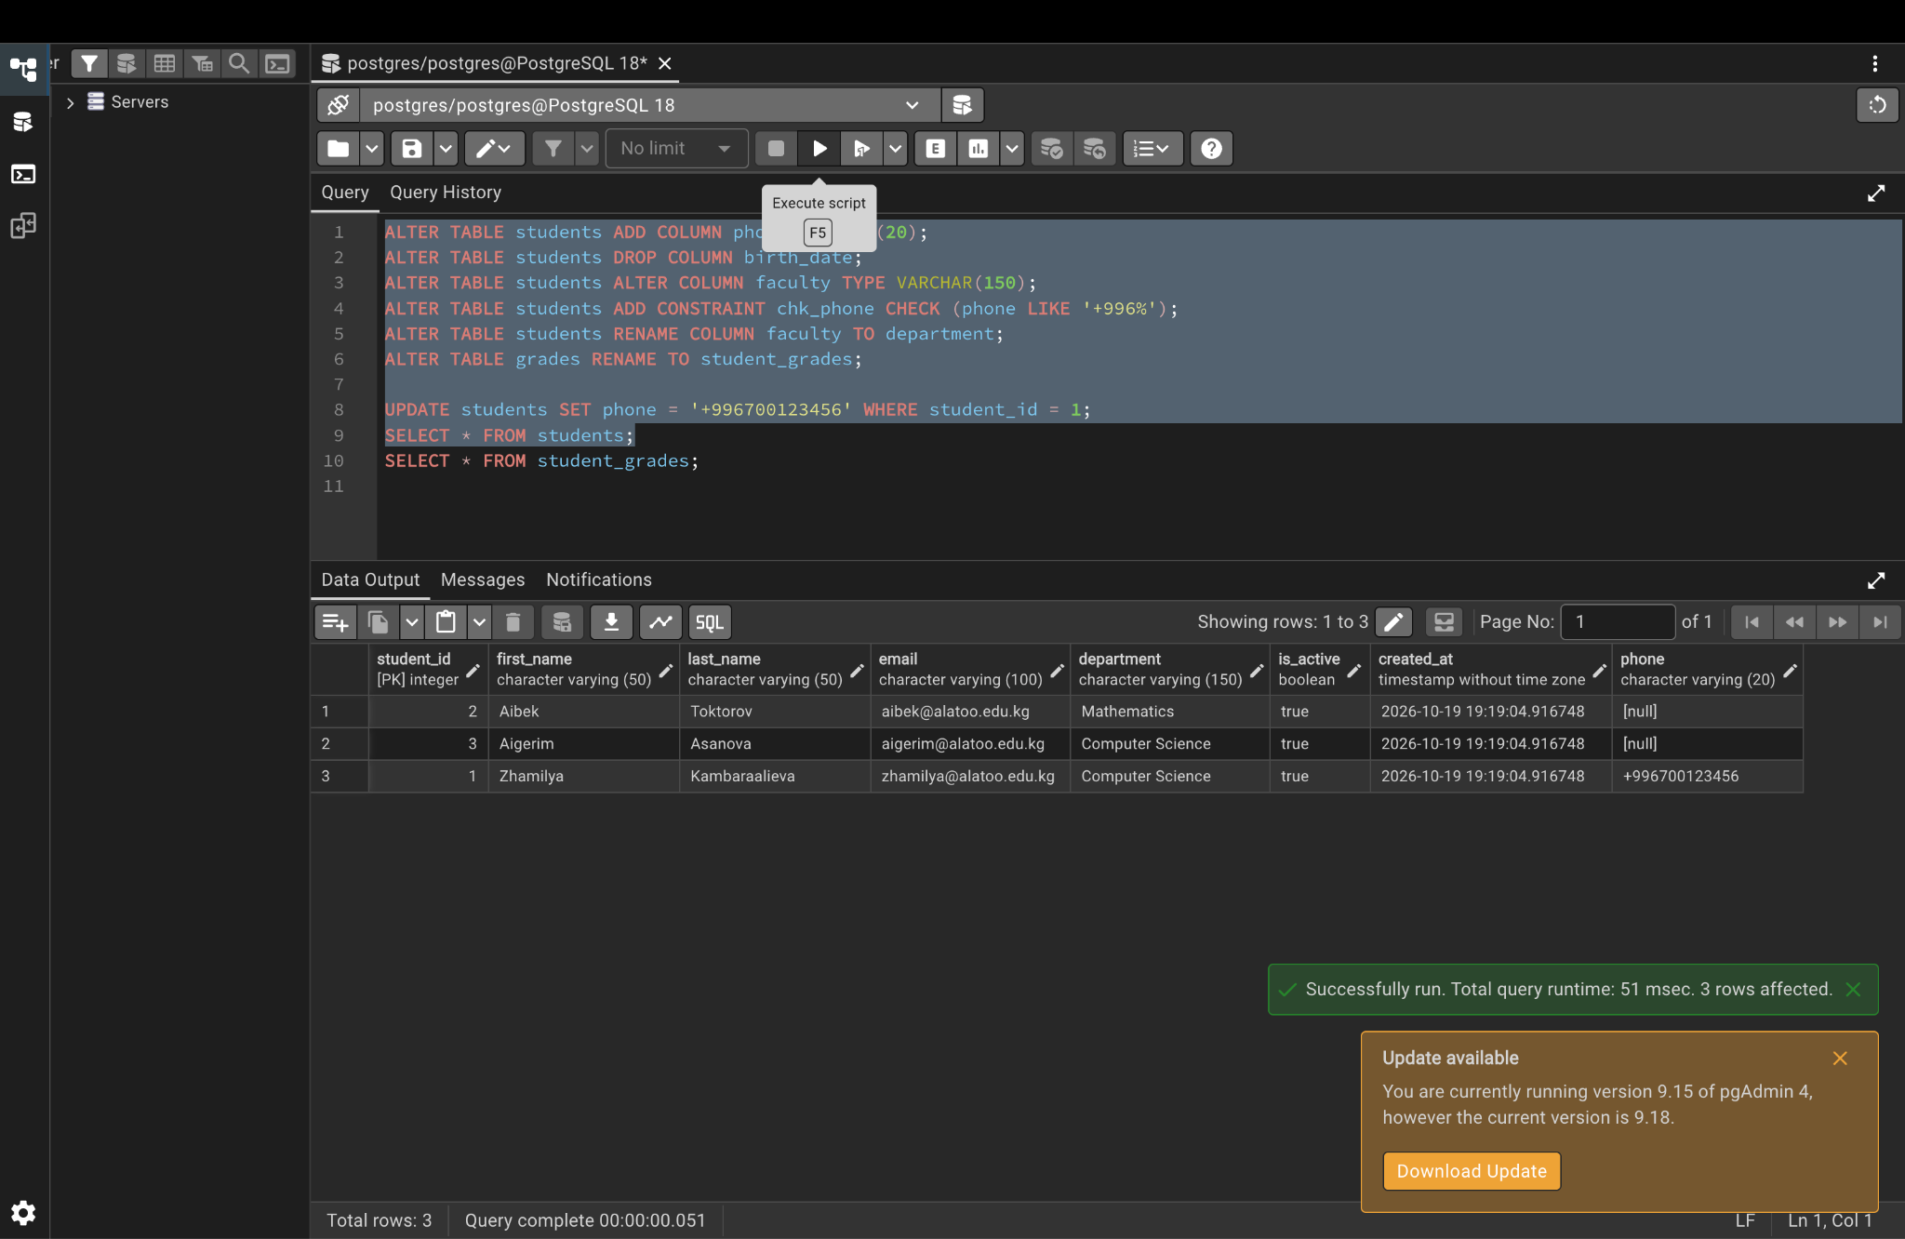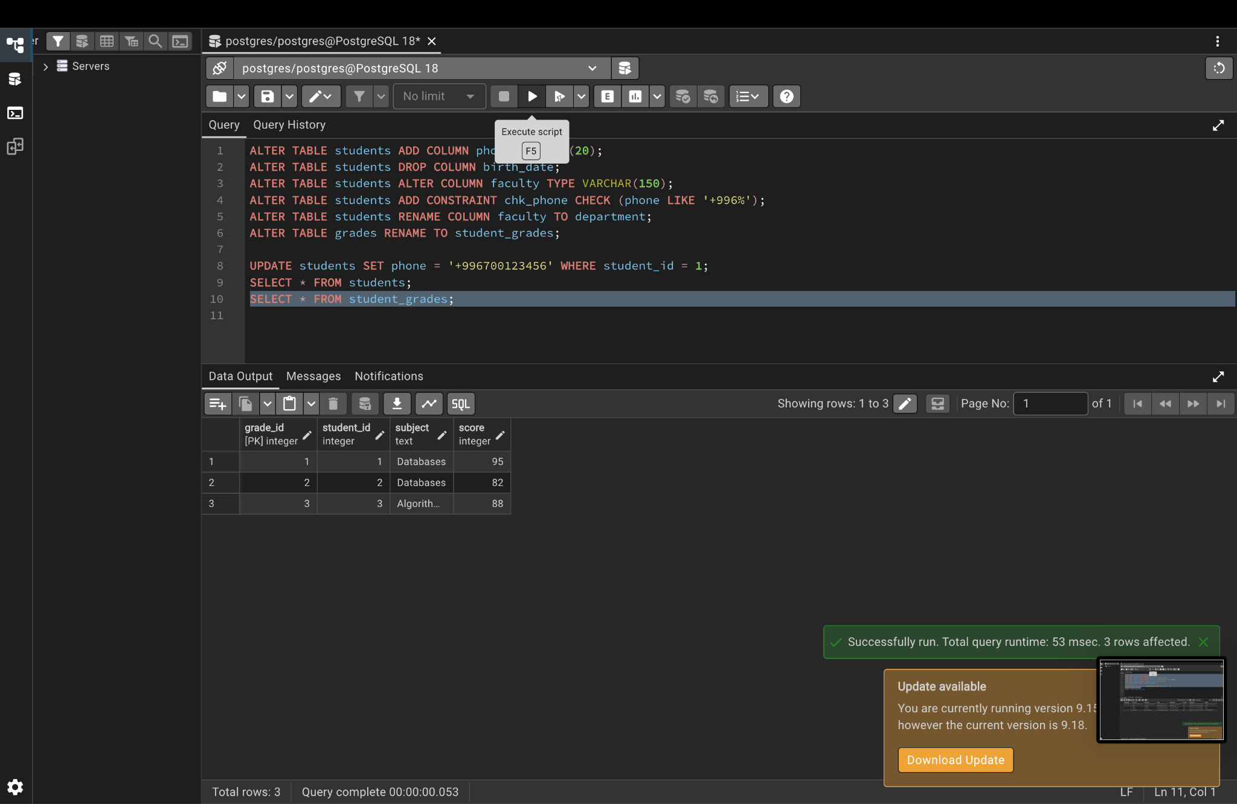

Step 5. Show the final table structure
SELECT column_name, data_type, character_maximum_length, is_nullable, column_default
FROM information_schema.columns
WHERE table_schema = 'lab6' AND table_name = 'students'
ORDER BY ordinal_position;
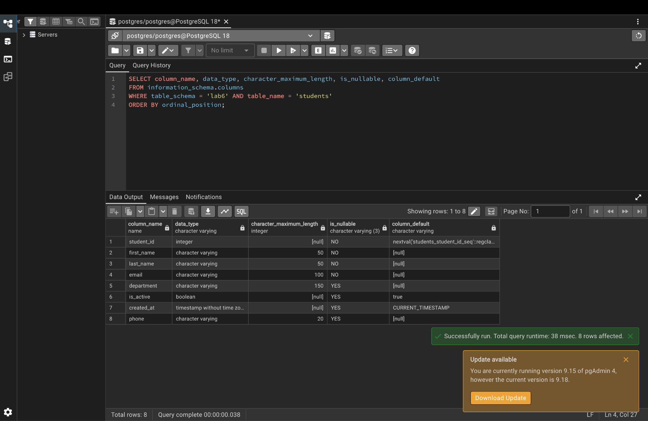

Part 3. Temporary tables and DROP TABLE

Step 6. Create a temporary table
It disappears automatically when the session ends.
CREATE TEMP TABLE temp_top_students AS
SELECT s.first_name, s.last_name, g.score
FROM students s JOIN student_grades g ON s.student_id = g.student_id
WHERE g.score >= 85;
SELECT * FROM temp_top_students;
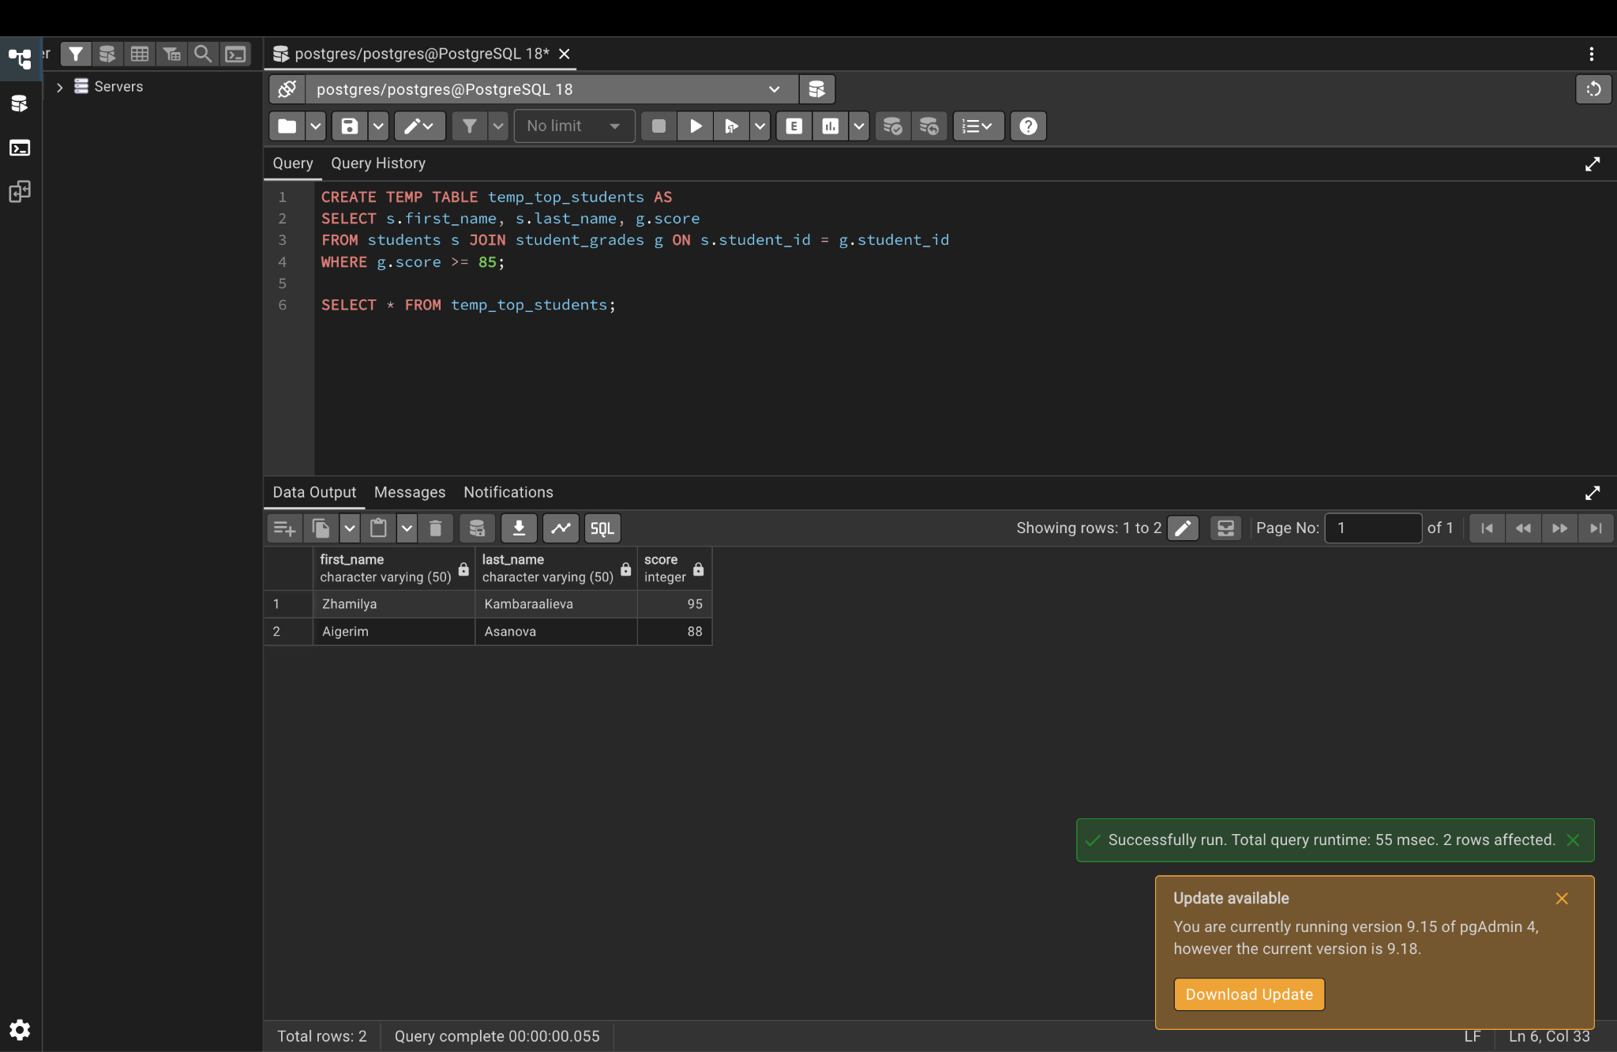

Step 7. Drop a table
The second DROP uses IF EXISTS, so it gives only a NOTICE instead of an error.
CREATE TABLE test_table (id INTEGER);
DROP TABLE test_table;
DROP TABLE IF EXISTS test_table;
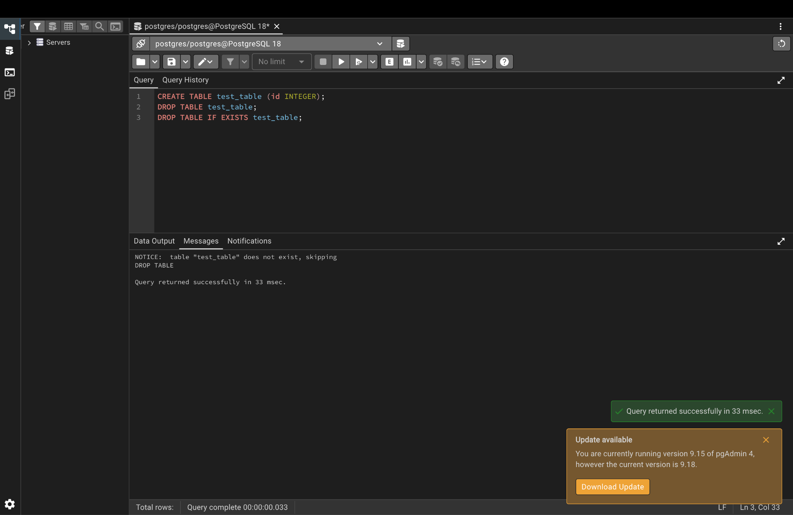

Part 4. Proving the constraints work (each command should give an ERROR)

Step 8. NOT NULL test
SET search_path TO lab6;
INSERT INTO students (first_name, last_name, email) VALUES (NULL, 'Test', 'x@alatoo.edu.kg');
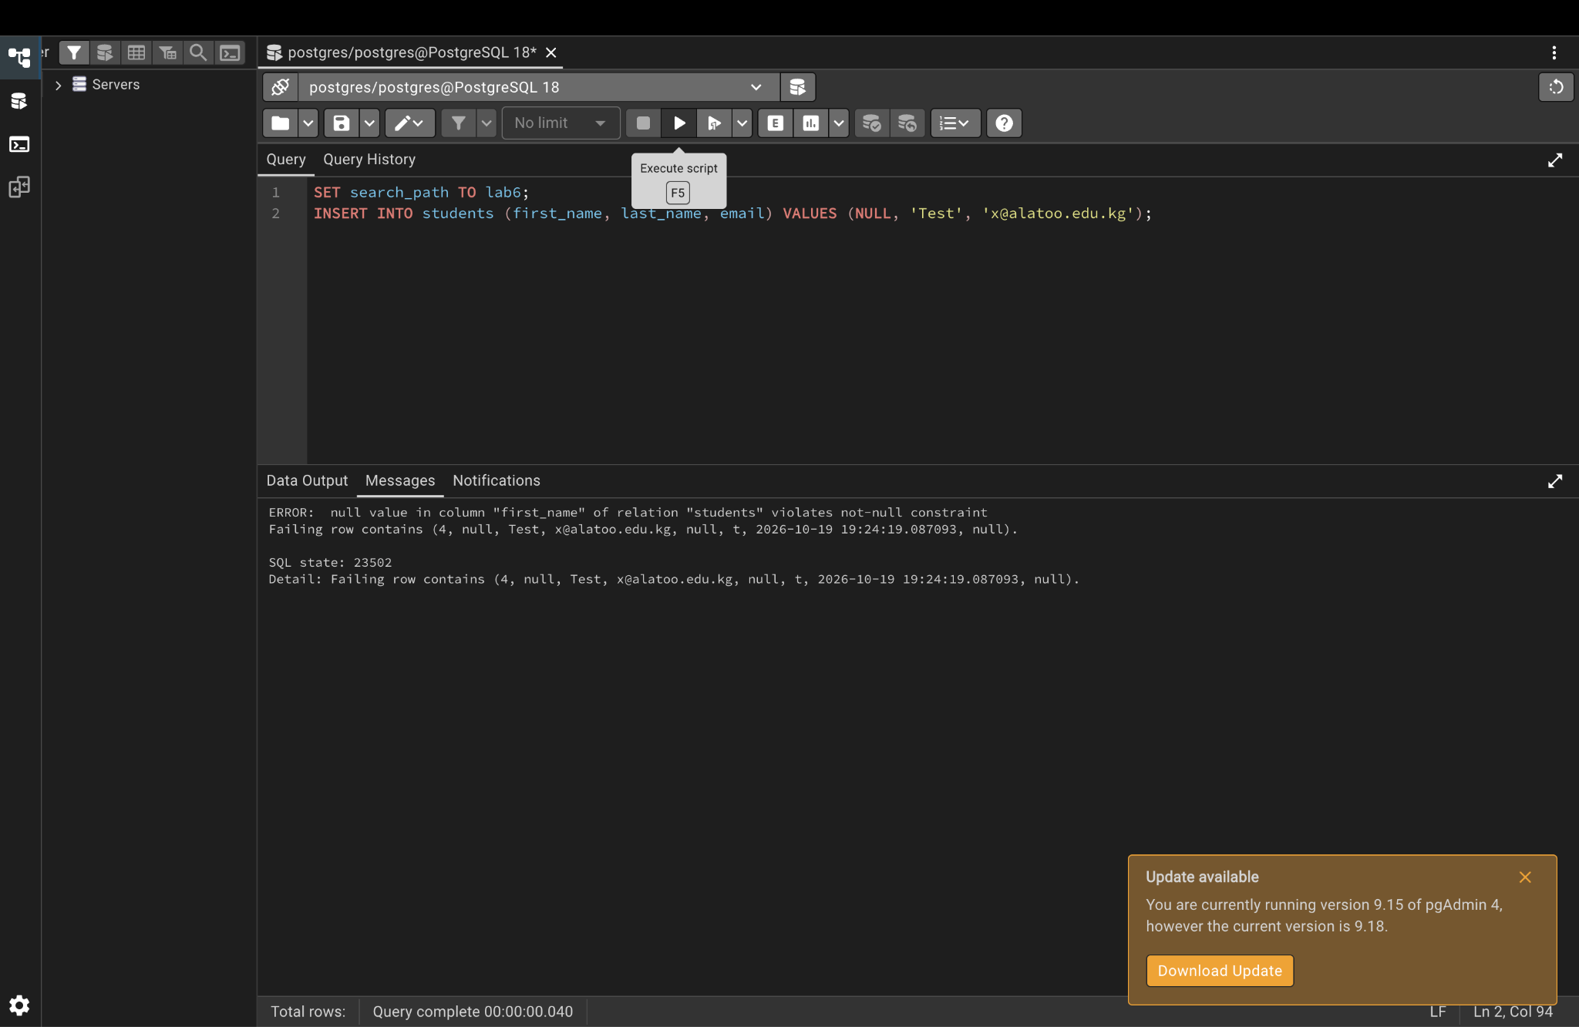

Step 9. UNIQUE test
INSERT INTO students (first_name, last_name, email) VALUES ('Copy', 'User', 'zhamilya@alatoo.edu.kg');
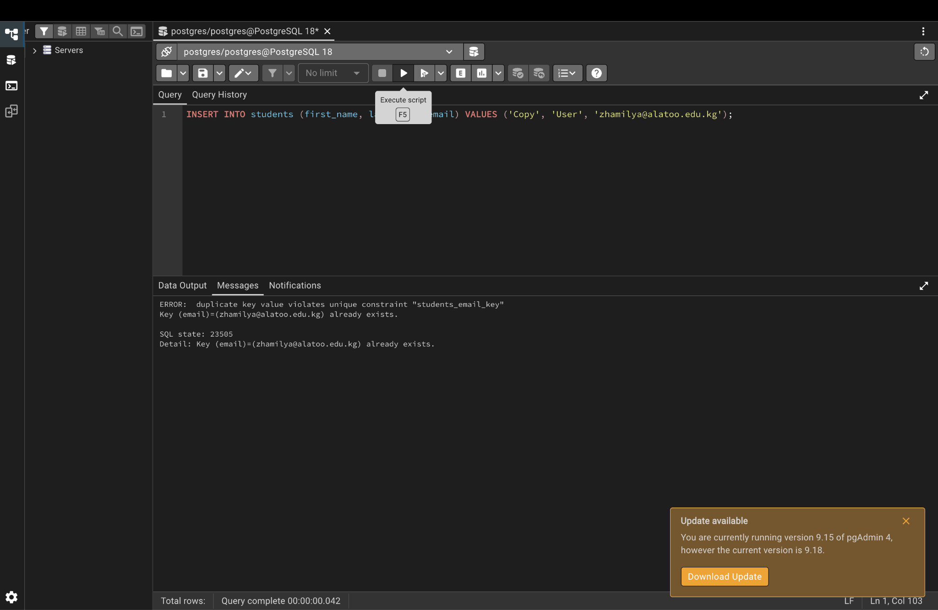

Step 10. CHECK test (score must be 0 to 100)
INSERT INTO student_grades (student_id, subject, score) VALUES (1, 'Physics', 150);
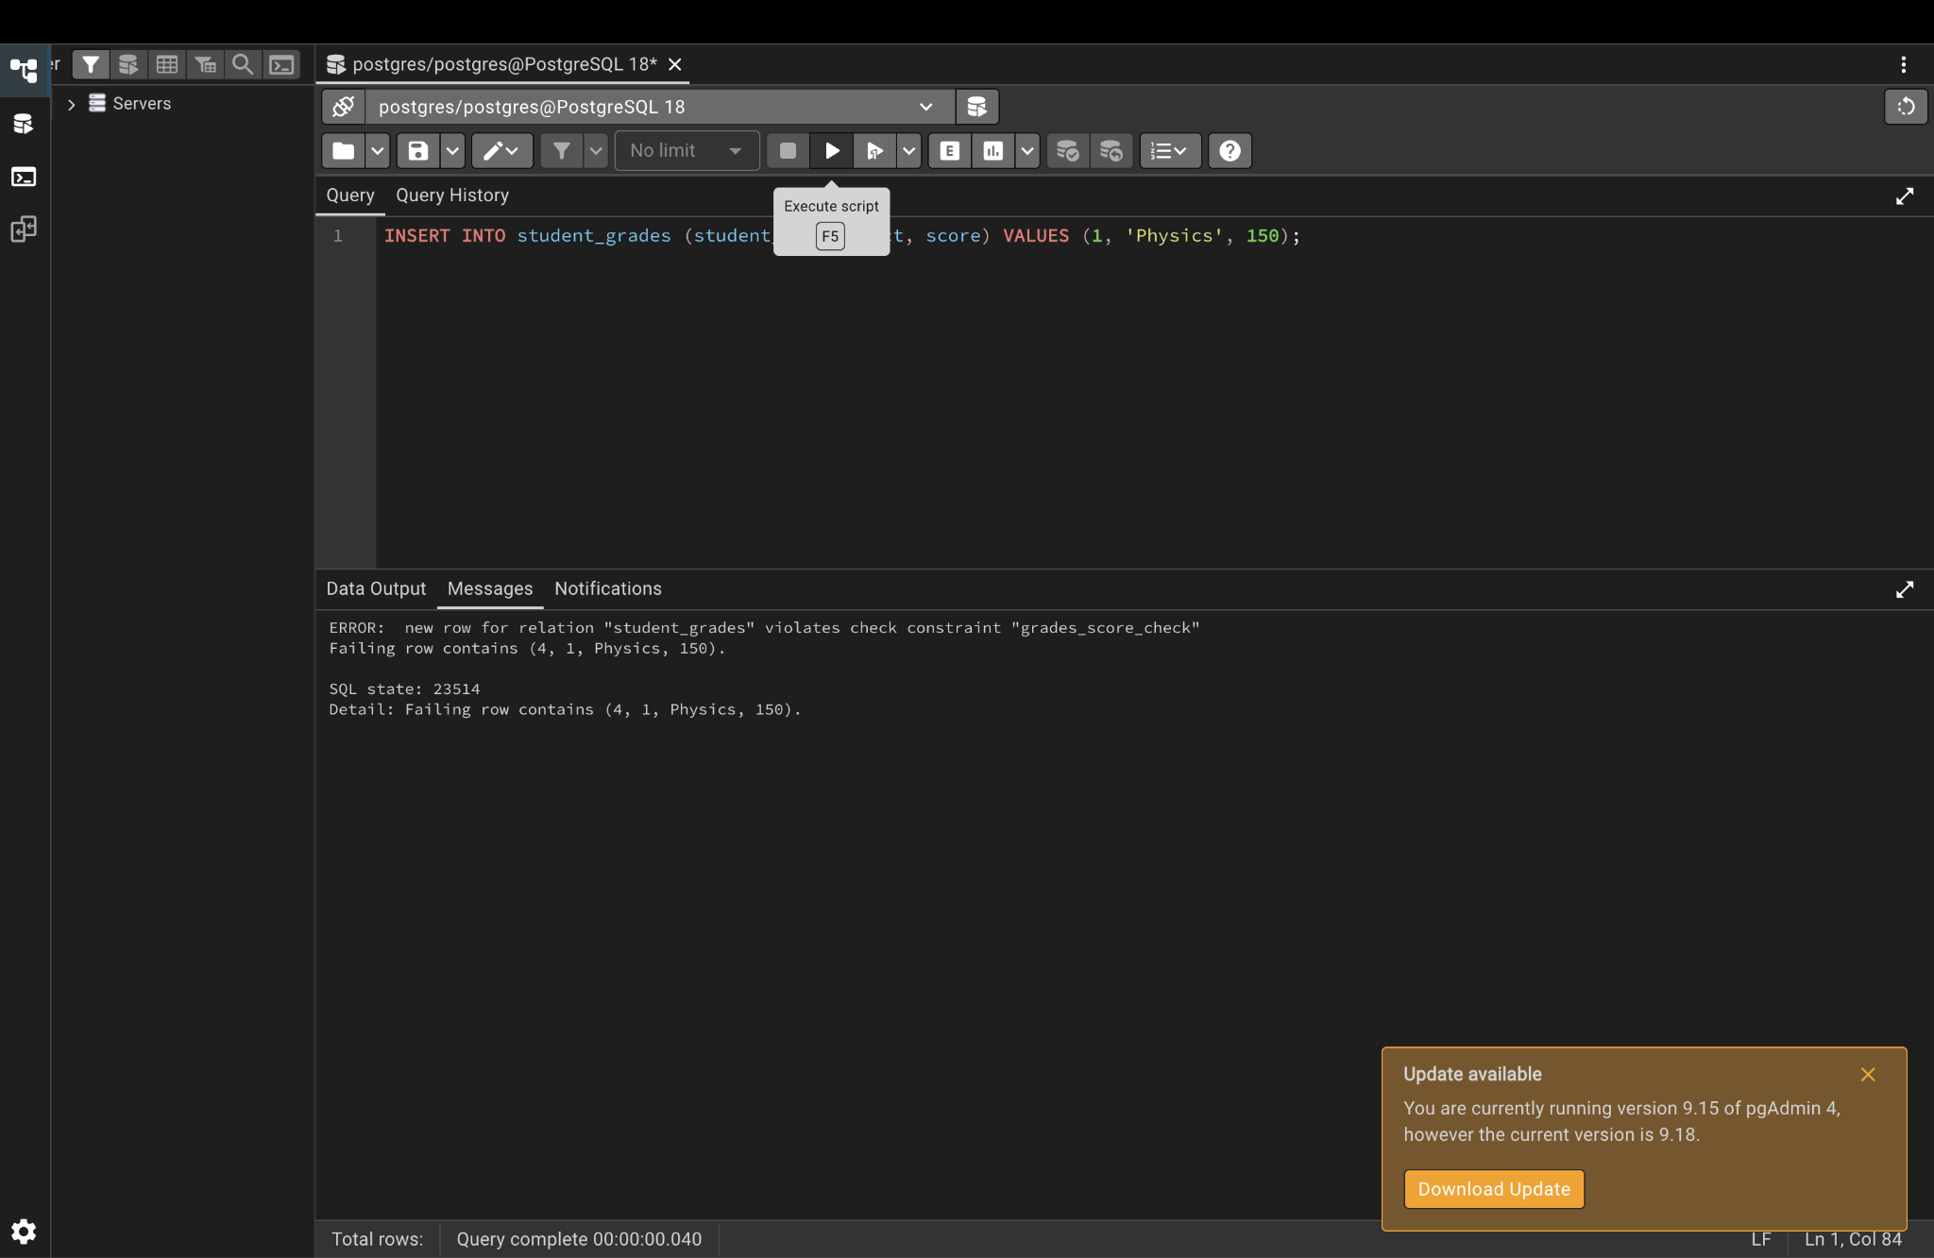

Step 11. CHECK test (phone must start with +996)
UPDATE students SET phone = '12345' WHERE student_id = 2;
